Assignment 1

SELECT customers.name AS customer_name, SUM(order_details.quantity) AS total_quantity_ordered FROM customers JOIN orders ON customers.customer_id = orders.customer_id JOIN order_details ON orders.order_id = order_details.order_id GROUP BY customers.name;

Assignment 2

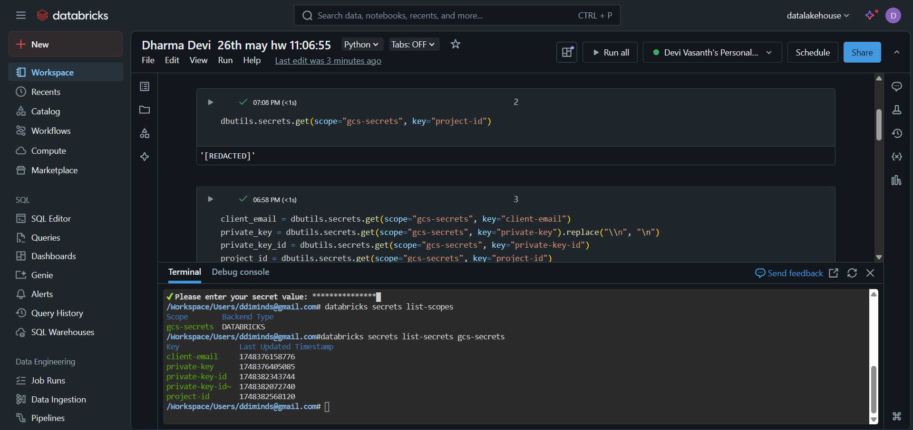

Hii Team, please find the homework.

<https://docs.google.com/document/d/15E2BGiOm39DXiWCPrJKDpapoO6RMgvGQ4wPdgRlTEgE/edit?tab=t.0>

https://youtu.be/ZnoUnibO2YQ

https://youtu.be/P7xZkDuiOVI